# What is a Firewall? IMG_256

A firewall is a network security solution that monitors and regulates traffic based on defined security rules and accepts, rejects or drops traffic accordingly.

## What Does a Firewall Do?

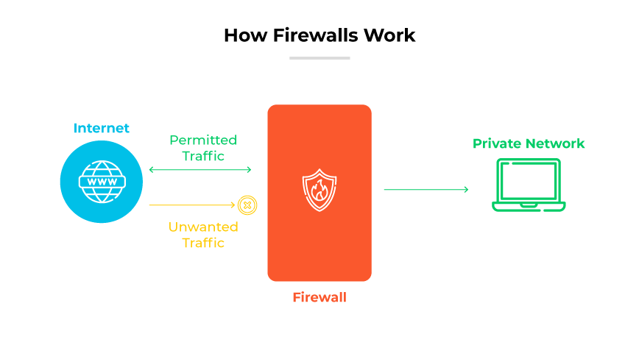

The function of a firewall is to secure network hosts by monitoring and managing traffic flow. Network hosts are devices (e.g., computers) that communicate within a network. Their exchanges can be within an internal network or between internal and external networks.

The role of a firewall in cyber security is paramount. It serves as the first line of defense, investigating and controlling network traffic to avoid potential cyber threats. By maintaining a vigilant barrier between trusted and untrusted networks, firewall systems are pivotal in ensuring the digital safety of an organization's assets and data.

Firewalls filter and inspect packets against their rule sets. If a packet doesn't meet the established criteria, entry is denied. A packet is a formatted piece of data equipped for online transmission. Packets transport all data transferred over the internet. They contain core data, information about the data's origin, destination port, and other relevant details.

## Types of Firewalls

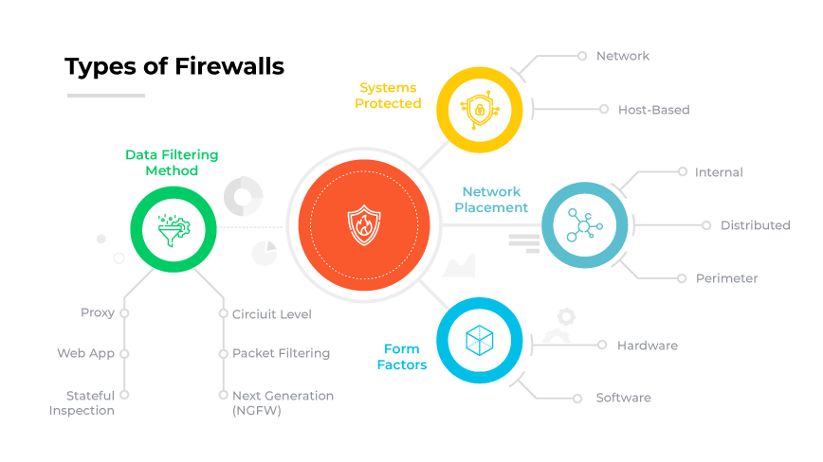

Firewalls are typically categorized based on systems they protect, form factors, placement within a network infrastructure, or how they filter data.

#### **Network Firewall**

Protects an entire network by monitoring and controlling incoming and outgoing traffic based on predetermined security policies.

#### **Host-Based Firewall**

Installed on individual devices or hosts, these monitor incoming and outgoing traffic from that specific device.

### Firewall Types by Form Factors

#### Hardware Firewall

A hardware firewall is a physical, individual device installed between network elements and connected devices.

#### Software Firewall

A software firewall is a software form factor rather than a physical appliance, which can be deployed on servers or virtual machines to secure cloud environments.

### Firewall Features

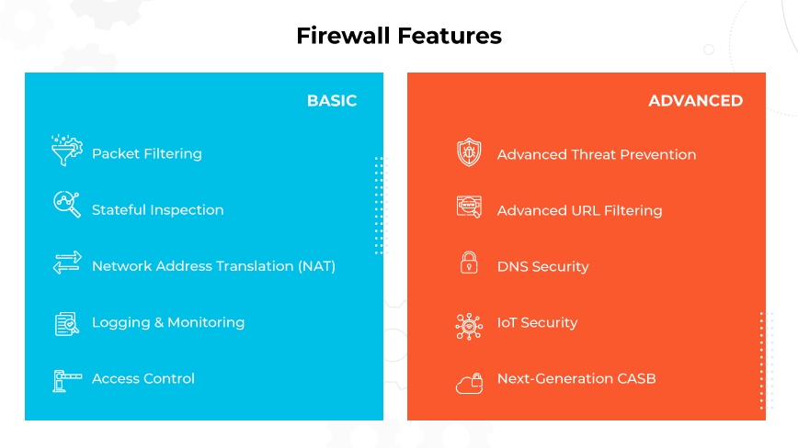

With evolving times, business protection methods must adapt. It’s important to note that traditional firewalls provide basic defense, but Next-Generation Firewalls (NGFWs), including ML-powered versions, reflect today's advanced digital threats. These firewalls blend old and new technologies for enhanced network security.

**Lets make one now**